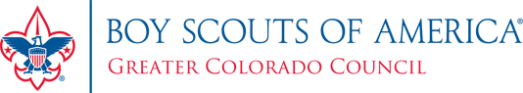
<Date, 2024>
RE: 2024 Scout Popcorn Sale
To Whom It May Concern:

Each year, Scouts from the Greater Colorado Council raise money to fund their Scouting programs through the annual fall popcorn sale.
This year, the Popcorn Sale will begin on <insert start date> and continue through <insert end date> for the traditional Show & Sell period.
With over 73% of the proceeds staying local, the purpose of this annual sale is to help Scouts earn funds for their yearly activities and provide program and camping opportunities to thousands of youth and volunteer adults in the Council’s area.
The Boy Scouts of America prepares young people for life by providing the nation’s foremost youth program of character development and values-based leadership training utilizing outdoor activity, citizenship, and sports fitness.
The Greater Colorado Council, Boy Scouts of America is a 501(c) 3 non-profit tax-exempt organization.
Will you help a Scout? How? By providing a small area outside of your establishment where Scouts may setup to sell their popcorn and create awareness about our programs and service in our communities. The Volunteer Adult Leaders will ensure the Scouts are trained to sell in a courteous and professional manner while you provide them the opportunity to practice their communication skills as they take on the personal responsibility of supporting their Scouting program. Scouts will be in uniform, have adult supervision, and maintain a clean sales area throughout the sale.
Should you have any questions or concerns, please do not hesitate to contact me. Thank you for your consideration of this request in support of our local Scouting programs.
Yours in Scouting,

