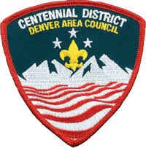

Centennial District
2022 Outstanding Leader Recognition

Please recognize up to 4 leaders from your unit. This award is not based on tenure or Scouting knowledge of the individual(s) being nominated but the demonstration of Scout spirit, energy and dedication to the delivery of the Scouting program by the individual(s) for our youth.

Outstanding Leaders will be recognized at the 2022 Adult Volunteer Recognition event to be held 23 February 2023.

Please return this nomination form by Monday, 23 January, 2023 to:

Denver Area Council, Attn: Centennial District
10455 West 6th Ave., Denver, CO 80215
Or
email: larsonkim303@gmail.com

__________________________________________________________________________
Name of Leader Unit and Number Position to be recognized for

__________________________________________________________________________
Name of Leader Unit and Number Position to be recognized for

__________________________________________________________________________
Name of Leader Unit and Number Position to be recognized for

__________________________________________________________________________
Name of Leader Unit and Number Position to be recognized for

