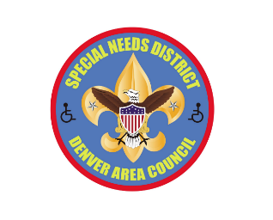
Why Scouting is a Great Program for Youths with Special Needs

- Scouting is a well-thought-out, highly structured program that provides a step-by-step sequence of skills for Scouts to Scoutmaster.
- Scouting promises fun, friendship, and adventure.
- Scouting offers frequent positive recognition.
- Scouting develops social skills and leadership skills.
- Through systematic Explanation,
interactive Demonstration,
and Guided practice,
Scouting Enables youth of all abilities to discover and develop their unique strengths and interests.

